**Project Management Documentation**

***Wrackful Code of Conduct***

***Git***

* All changes that are made to the mod or any of the surrounding documents must be committed on a regular basis.
* At the end of any session of work, all changes must be committed and pushed to the git repository https://github.com/Voxtric/Skyrim-Mod.
* No merge with the master branch should be made unless it has been approved by all members of the team and will not break the mod in its current state; the master branch should always be a valid Skyrim mod.

***Work***

* When work is set for a team member, it will be recorded in the minutes of the following meeting.
* All work must be completed within the time scale that is set out for unless there is adequate reason for it not to be. In these cases, the extension will be recorded in the minutes of the following meeting.
* Everything regarding the mod is up for discussion at any point, however the further past a point in development any one feature is, the less willing to change it any one team member should be.
* Attendance of each of the seminars must be made at 11:00 and attended until the end at 13:00. Attendance can however be excused with prior notice, however the absence will be recorded in the minutes.
* All team members are asked to try and make as much time for working on the mod as possible following the end of the 11:00-13:00 seminars if possible, however this is not mandatory.
* At the end of the project, all team members will be required to review every other team member and provide them with said review so that they may include it in their project reflection.

***Breach of Code of Conduct***

* Failure to adhere to all the rules outlined above will result in its notation in the minutes of the following meeting.
* The offending party will be required to provide an adequate excuse for the breach of the rules at the earliest possible time.
* Repeat offenders will be barred from working on aspects of the project that they have performed to the detriment to, and will be noted in the reflections of other team members at the end of the project.

***Wrackful Minutes – 01/02/2016***

**Recorded By:** Benjamin Drury

**Attended:** Benjamin Drury

Callum Gambles

Chris Atkins

**Items Discussed:**

* Rough plan for the mod including where much of it will be set and how it will tie into the main story.
  + A minimum of three environments: One wizard’s house, one Dwemer dungeon, and one large underground cave environment.
  + Some form of artefact designed to give the player access to the larger underground cave environment obtainable only upon completion of the initial quest for the wizard “Auxentius Bithnus”.
  + The main quest will involve a faction of the Dwemer practising advanced mixtures of both mechanical engineering and magic.
* Using Benjamin Drury’s machine for development of the actual mod as it is both more powerful and has more screens making development with the Creation Kit much more stream lined.
* The design of the mod will be left open ended so that, depending on how much time is left available after the main points of development are completed, more content can be added stemming from the larger underground cave environment.

**Actions Decided:**

* Each member should continue following the tutorials for the Creation Kit online for the following few weeks.

***Wrackful Minutes – 02/03/2016***

**Recorded By:** Benjamin Drury

**Attended:** Benjamin Drury

Callum Gambles

Chris Atkins

**Items Discussed:**

* Time plan and roles for the following two weeks work flow.

**Actions Decided:**

* Ben will make Gantt Chart of work time.
* Callum will finish Auxentius Bithnus' home exterior and interior.
* Chris will write up the quest story and dialogue to fill it out.

***Wrackful Minutes – 09/03/2016***

**Recorded By:** Benjamin Drury

**Attended:** Benjamin Drury

Callum Gambles

Chris Atkins

**Items Discussed:**

* Time plan and roles for the following two weeks work flow.

**Actions Decided:**

* Ben will update Gantt Chart and produce a questionnaire for everyone to fill out and review each other at the end of the project.
* Callum will start actually implementing the Dwemer dungeon interior cell.
* Chris will continue to write up the store elements of the quest.

***Wrackful Minutes – 13/04/2016***

**Recorded By:** Benjamin Drury

**Attended:** Benjamin Drury

Chris Atkins

**Items Discussed:**

* Time plan and roles for the following two weeks work flow.

**Actions Decided:**

* Callum will continue working on the Dwemer dungeon interior cell.
* Benjamin will re-add all quest dialog and voice acting.
* Chris will build the interior of the Dwemer dungeon once Callum has finished the exterior.

**Implemented Quest Dialogue**

AUXENTIUS BITHNUS:

1. Are you the messenger? Do you have my package? <Surprise 70>
2. I can't say. It's important. Very important. Life or death even. <Fear 50>
3. Ah. I think my package has been stolen! Why isn't it here? <Anger 50>
4. Yes! I think that buffoon Falion may know something. Ask him. Now. <Happy 80>
5. If you know someone that can, send them to me as soon as possible. I need that package! <Disgust 80>
6. No. Now, away with you! <Anger 50>
7. You do? Give me it! Now! <Happy 100>
8. Thank you oh thank you! You shall be rewarded greatly! I can finally leave my mark upon Skyrim. <Happy 80>
9. What? Don't make me laugh, you're pathetic! I'll just take it from you! <Disgust 100>
10. You're back! Don't just stand there then, what is the news? <Surprise 50>
11. What? Then get back out there and find out where my package is! <Anger 80>
12. Yes! Thank you! Now, could you go and maybe get it for me? I can pay, and well at that! <Happy 90>
13. Unacceptable! Get out of my sight and find me someone that will then! <Anger 100>
14. Excellent! Hurry and get that package for me then. Take this and get back with the package as soon as possible! <Happy 100>

JARL OF MORTHAL:

1. What is it? We don't usually seize items. <Puzzled 60>
2. Yes, an artefact of this strength should definitely remain out of the hands of mere common men. For your services, you have my thanks. <Fear 60>

FALION:

1. No, I'm afraid not. Packages often go missing in this part of Skyrim. Gorm usually has his nose in business where it doesn't belong, try asking him. <Disgust 60>

GORM:

1. Afraid not. Try Jonna, she's the innkeeper so she hears a lot. She's Falion's sister too, I'm surprised he didn't send you straight to her. <Sad 40>

JONNA:

1. Gorm did? I don't think so, sorry. I know you've been on a goose chase but try Jorgen, he may know. <Puzzled 40>

JORGEN:

1. Ah yes, Auxentius the mad milk drinker. No, I don't know anything. Why would I? <Surprise 60>
2. Okay, so maybe I heard that a courier went missing along the route from Mor Khazgur to Solitude as no one has heard from him since he set off. <Surprise 50>
3. That there is. I heard that a courier went missing along the route from Mor Khazgur to Solitude. You should try checking along that route. <Happy 80>
4. Look, between you and me, I wouldn't trust your new friend. If I know him, that package isn't good news, so I'd consider not letting him get it. <Fear 50>

***Planned Gantt Chart Actual Gantt Chart***

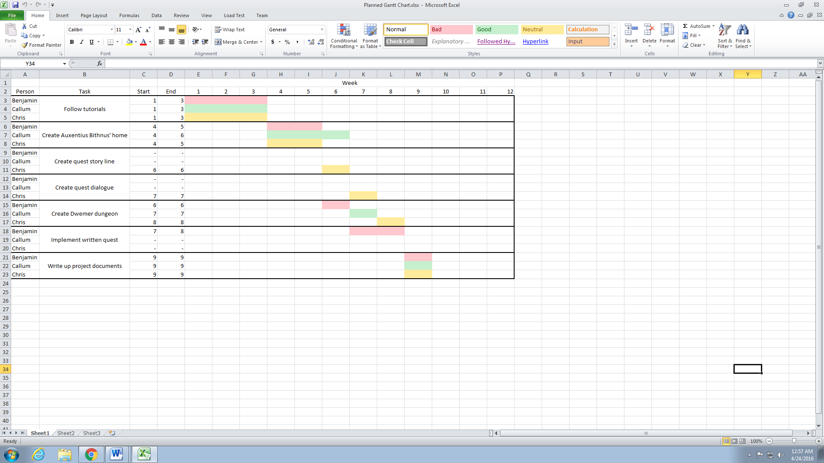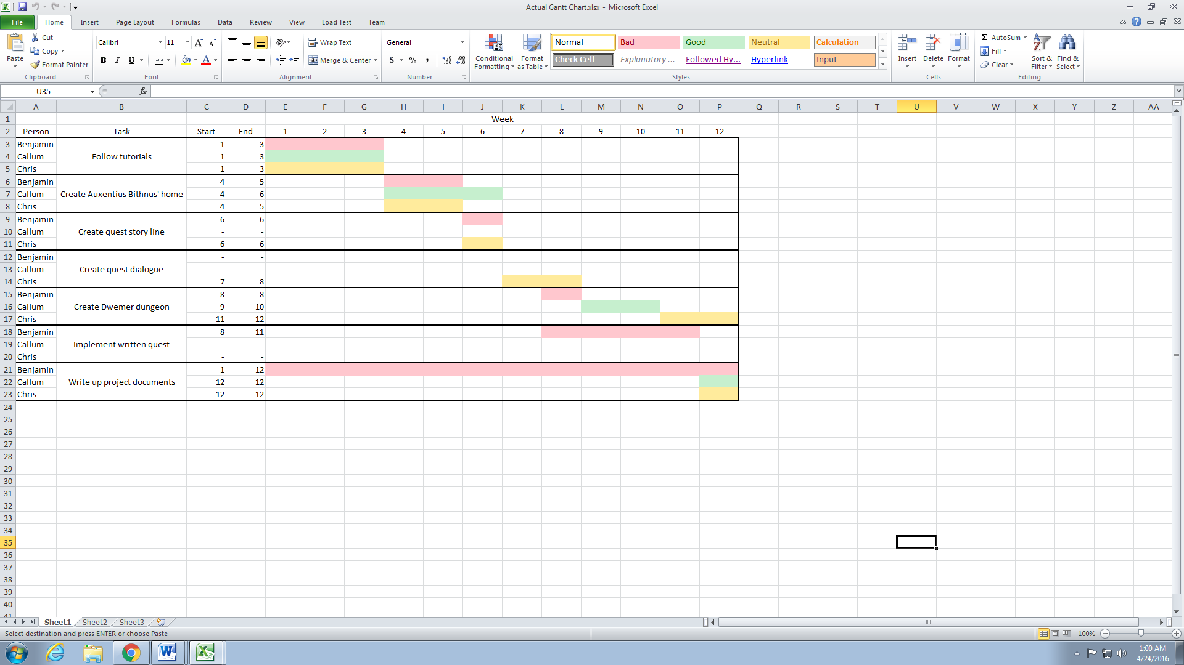

**Individual Reflection - Benjamin**

At the beginning of creating the mod for Skyrim once we had got the team together, we quickly discovered that we were all very compatible with each other and immediately set about coming up with ideas for the mod. Everyone on the team was willing to contribute ideas to the project whilst still be opening to other members of the group’s ideas which meant we were able to quickly draw up a plan for the mod. Have put together this plan that we all had in each of our heads, we all threw ourselves into working on the mod, however whilst minutes for this first meeting were recorded, a design document was never created.

This lack of design document definitely hindered us in the later stages of the mods development as without clear objectives to head towards, time quickly began to escape us as the project went on. This can clearly be seen in the Gantt Charts included in the ‘Project Management Document’ above where, the longer the project went on, the more we deviated from it. Unfortunately Callum’s PC failed him, meaning that creating the Dwemer dungeon took far longer than had initially been expected. On top of that, the bugs and lack of documentation on how to get round many of them in the Creation Kit caused significant delays in implementing the quest. This caused the quest to have to be re-implemented from scratch by myself twice just to get objective markers to work. Between these three factors and many other minor ones, the group was not able to stick to the original times planned.

That said, as previously mentioned we did keep minutes of each proper meeting that we had and what was discussed in each, all four of which can be seen in the above ‘Project Management Document’. Whilst each of the meetings were undeniably helpful, and we really should have kept more to keep the project on tack from start to finish, in the end the minutes were ultimately nothing more than a little bit extra work. As each member of the project was fairly trust worthy on remembering the tests and completing them, the minutes really were never used.

On the subject of meetings and as mentioned previously, we really could have done with more meetings to keep the project on track. If we had all decided to come in and discuss where we were up to on a more regular basis, there may have been fewer delays between the completions of some elements of the project. This group based time management could have worked to ensure that we were closer to the planned Gantt chart by the end of the project, though in the end it didn’t really matter.

As the group was built from two different courses, Callum and Chris being designers and me being a programmer, splitting the development of the mod up became a very simple task. This splitting up of roles is something we stuck to pretty much throughout the entire course of the mod development. Callum and Chris handled most of the creative side of the mod such as designing and creating the dungeon and me implementing the quest dialogue and scripts and doing the write ups. This worked well for all of us as it meant we all got to avoid the bits that we particularly disliked and contribute our strengths much better to the project.

Another point that the group was particularly good at was maintaining communications, especially over the holidays. Each person was able to regularly keep the others up to date on how their work was going via Facebook so everyone in the group knew roughly how far the project was along. This made it much easier to decide on courses of action to get the mod’s development back on track when it started falling behind. This was especially good following the holidays as that is when the development of the mod really began to fall behind.

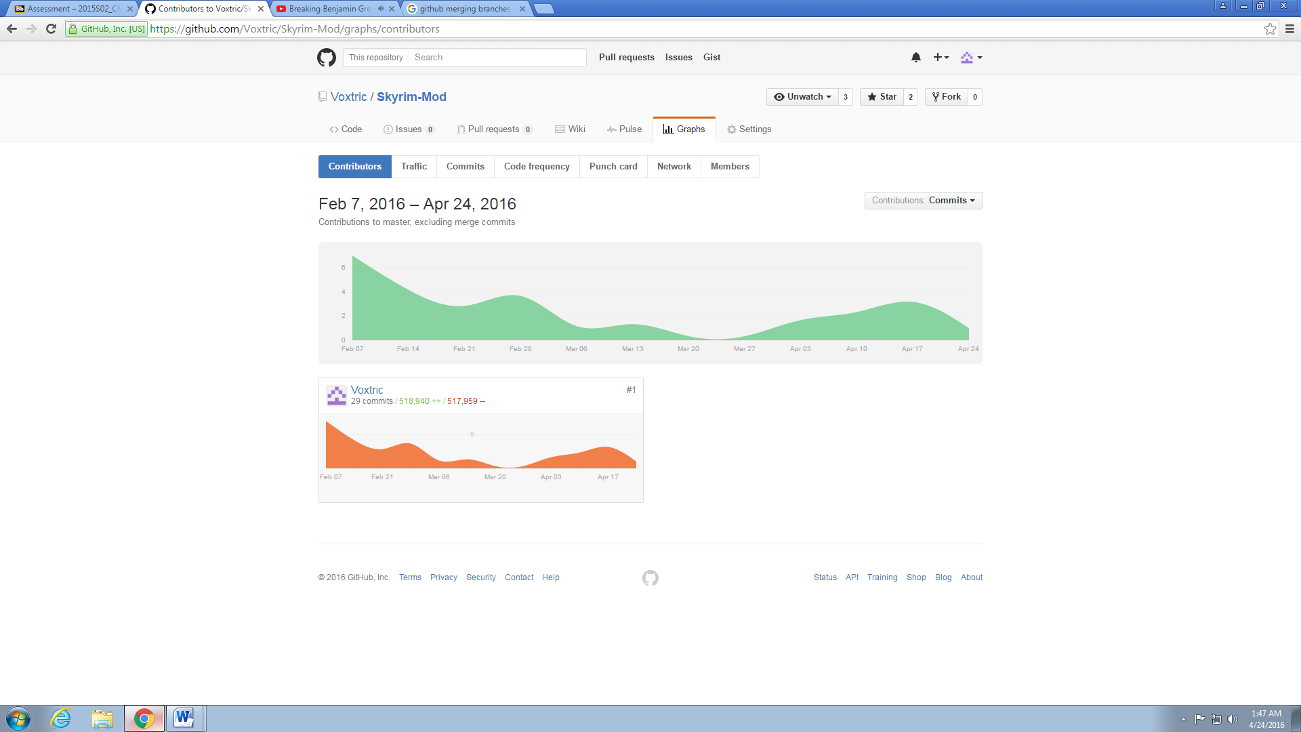Initially we had planned to use Github to store everything to do with the mod, and the code of conduct reflects that initial desire to do so. However, as can be seen in the image to the right, this never really happened as I was the only one who ever pushed their progress with git. This was no issue in terms of getting the mod files to each other as in the end they were all just shared via Facebook. However if we were to do a project such as this in the future, I would insist that everyone actually stuck to the initial plan and used git as it makes it far easier to keep track of who is doing what and when.

A plan that we tried at the beginning of the project to try and ensure the best quality was for each person to implement their own version of each goal, and then combine the best ideas from all into the final mod. Whilst not very time efficient, the idea was that it would mean that everyone’s best takes on the same idea would make it into the mod. Unfortunately there were instantly time delays just trying to make the cottage for Auxentius Bithnus, and issues with the Creation Kit meant no one was willing to put more work in using it than was absolutely necessary. Subsequently, we dropped this idea before Auxentius Bithnus house had even been finished initially, but we did learn not to try ideas such as that in the future.

Other things learned from this project include the importance of ensuring that you are totally on board with an idea before throwing yourself into it, as it’s impossible to put your best effort into something you’re not bothered about. As someone who personally does not enjoy playing Skyrim, nor I enjoy using broken software, this project on the whole was very hard for me to invest myself in. I of course gave the best effort I could to it, but I took several short cuts to avoid using the Creation Kit such as cutting unnecessary dialogue which potentially could have harmed the feel of the mod. Arguably such cuts were necessary to keep ourselves as close to a viable time frame as possible, but one does wonder never the less.

If we were to do the project again in the same time span, I would like to think that everything would go a lot smoother from the start as, now that we are all familiar with the Creation Kit, we would be able to avoid many of the plethora of issues that it has. Also, I’d make sure to try and manage everyone’s time a lot better so that we would have enough time to include more content into the mod. As it stands at the moment, the mod works and is for the most part polished, but it largely lacks anything that makes it particularly unique. The quest is just another dungeon explorer artefact retrieval quest, something that Skyrim already has far too many of. Given the opportunity to do this module again, I would definitely try and go for more of a unique selling point for the overall idea of the mod.